**S**TOCK

**W**ITHDRAWAL

**A**DVICE

By :**FELJUN BUENO**

Before you can enter the program a SECURITY CHECK will appear to verify your user name and password.

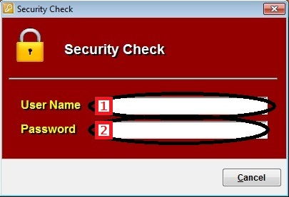

**File Maintenance**

1. To set-up Subsidiary code, from the main menu select FILE MAINTENANCE > SUBSIDIARY.

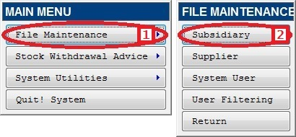

1. NEW SUBSIDIARY. Click NEW, then type the desired subsidiary code and description. Click SAVE to save entries made.

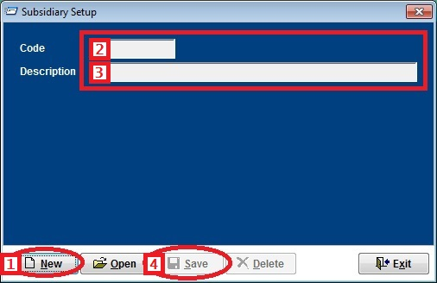

1. EDIT / DELETE EXISTING RECORD. Click OPEN, then select subsidiary you wish to modify, then click on the check mark or press enter.

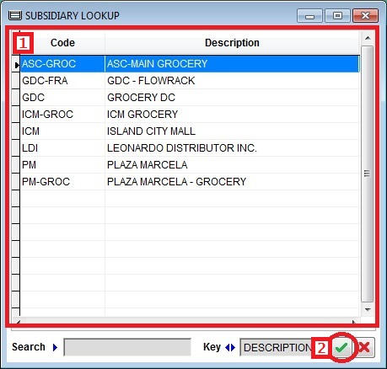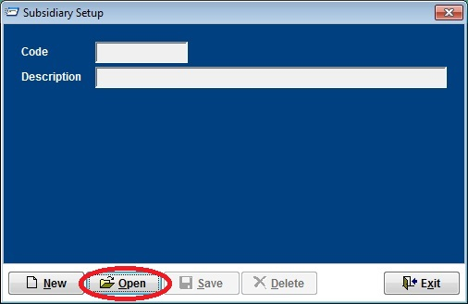

1. After all the changes made. Click SAVE / DELETE to save the changes made.

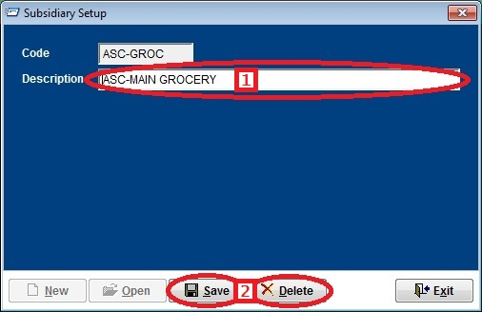

1. To set-up Supplier/Vendor code, from the main menu select FILE MAINTENANCE > SUPPLIER.

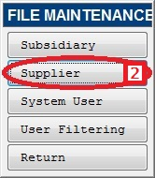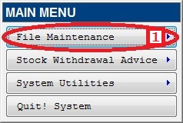

1. NEW SUPPLIER. Click NEW, then type the desired supplier code and description. Click SAVE to save entries made.

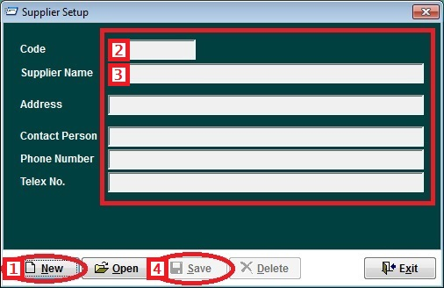

1. EDIT / DELETE EXISTING RECORD.
   1. Click OPEN and select supplier you wish to modify, then click on the check mark or press enter.

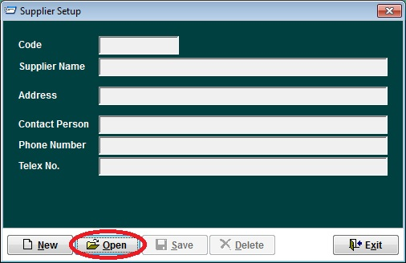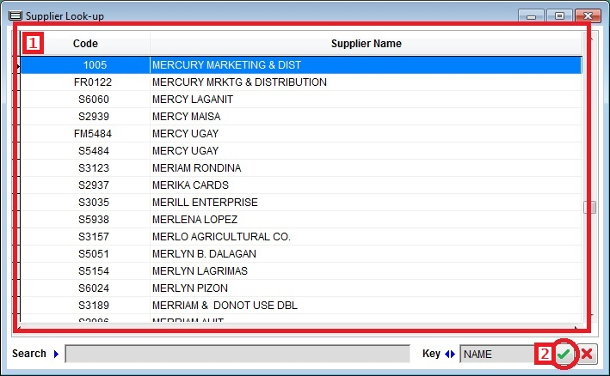

* 1. After all the changes made. Click SAVE / DELETE to save the changes made.

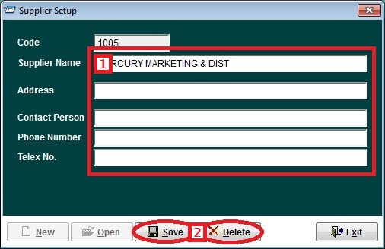

1. To setup new User, from the main menu select FILE MAINTENANCE > SYSTEM USER.

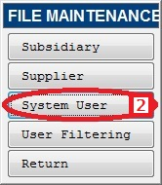

1. NEW USER. Click NEW, then type the user name and click on the magnifying glass icon to select the user class, then click on USER PASSWORD and type the users password.

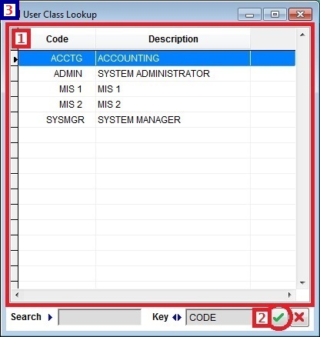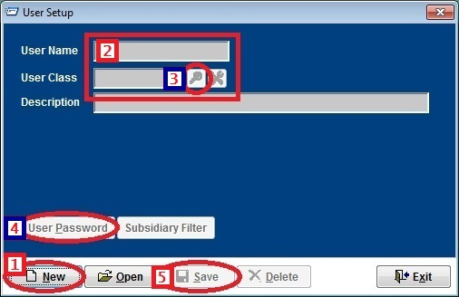

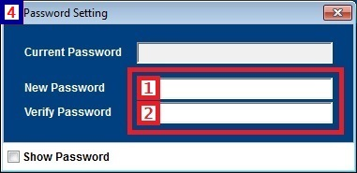

1. EDIT / DELETE EXISTING RECORD.
   1. Click OPEN then select the user you want to edit.

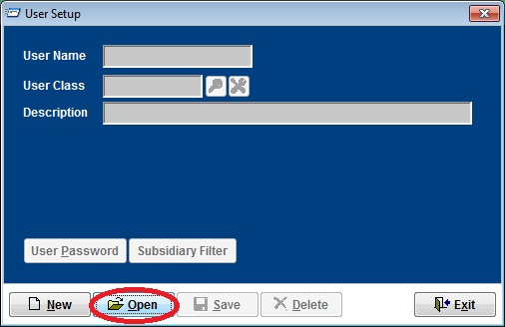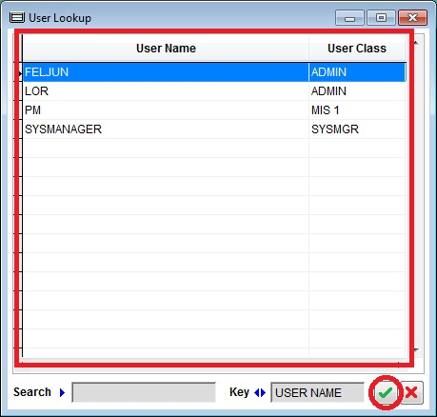

* 1. After all the changes made. Click SAVE / DELETE to save the changes made.

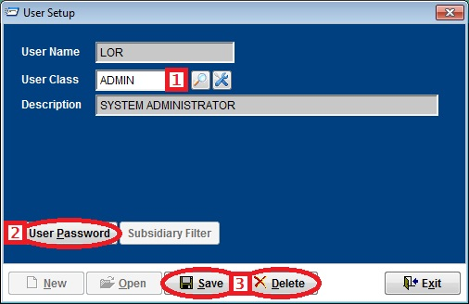

1. To setup User Filtering, from the main menu select FILE MAINTENANCE > USER FILTERING.

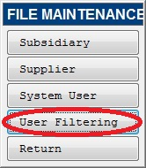

1. Click NEW button, then click the magnifying glass icon to select a user.

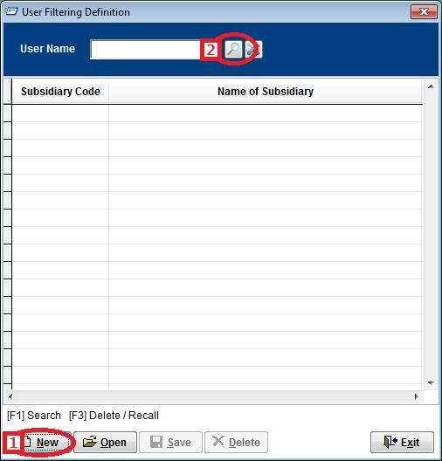

1. After you’ve selected the user name, type the subsidiary code or press F1 to select a subsidiary the user is only allowed to use.

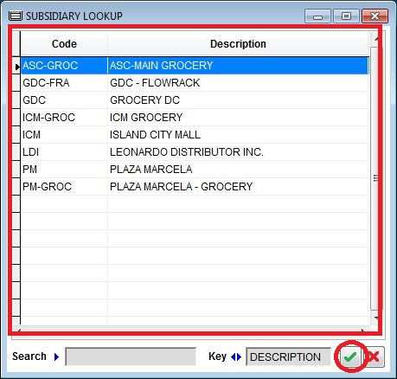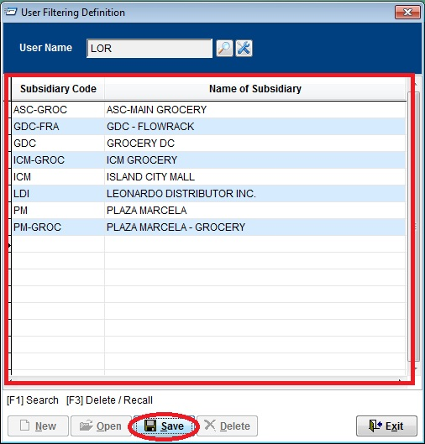

**Stock Withdrawal Advice**

1. To enter stock withdrawal advice form, from the main menu click on STOCK WITHDRAWAL ADVICE > SWA FORM.

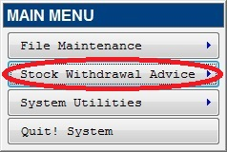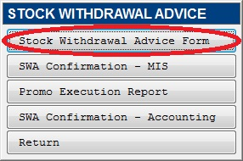

1. To create a SWA form
   1. Click on the NEW button
   2. Type the current date
   3. Select from location (GDC, WDG,LDI/DSG, Store, etc.)

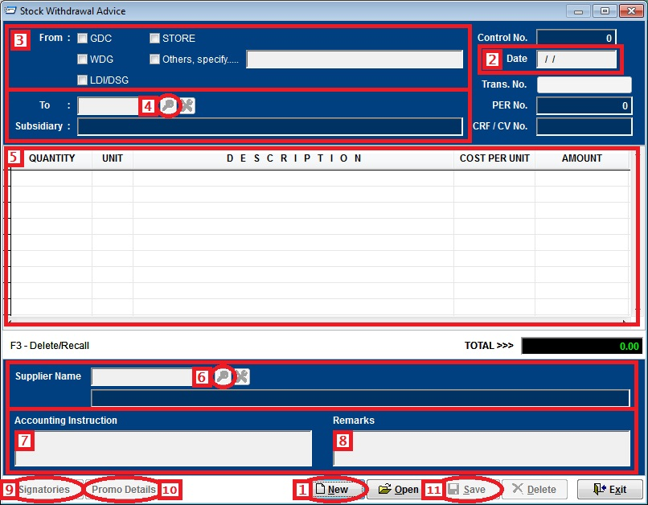

* 1. Click on the lookup button to select a subsidiary

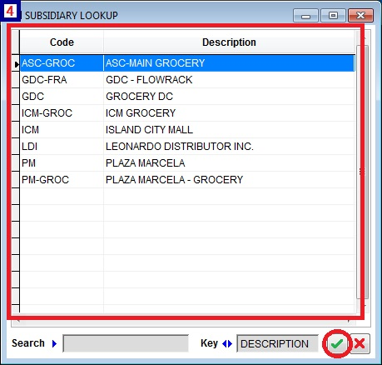

* 1. Enter the item description, quantity & the unit cost to be withdrawn from the location.
  2. Enter the supplier code or click on the lookup button to select a supplier to where the item/s withdrawn to be charged.

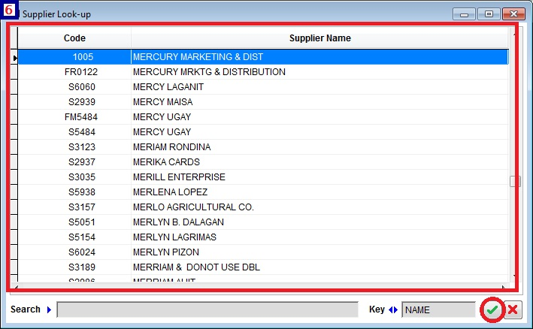

* 1. Enter the accounting instruction
  2. Enter the remarks you wish to add
  3. Click on the Signatories button to enter the signatories & date
  4. If the items withdrawn is to be used for promotional purposes. Click on Promo Details button to enter the promo title, mechanics & the duration of the promo.

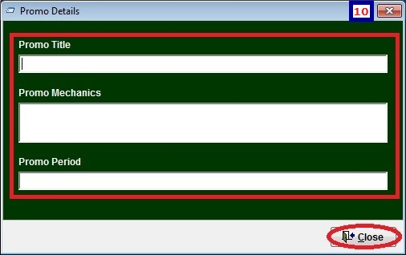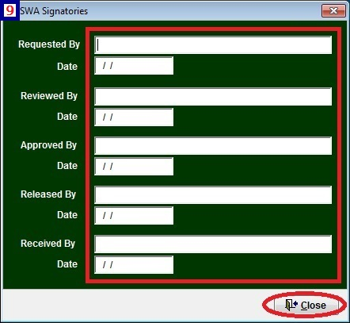

* 1. Next is to save and print the SWA form. Just click on the SAVE button, then follow the steps bellow.

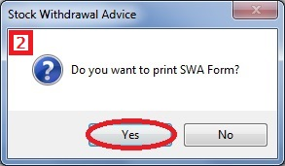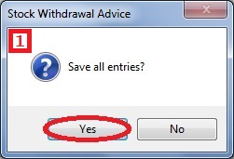

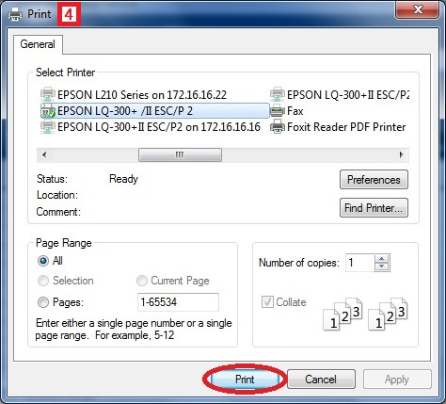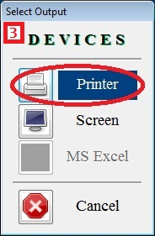

1. To open an existing SWA form
   1. Click OPEN button.

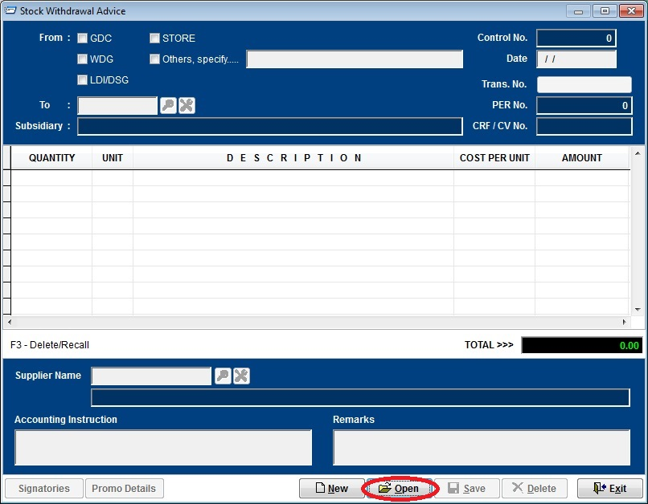

* 1. Select previous SWA entries. Then click the CHECK button to select.

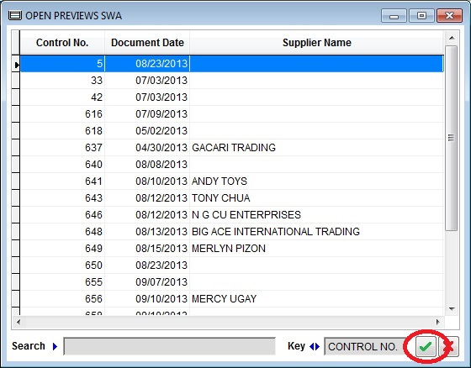

* 1. Click CLEAR button to clear the screen.

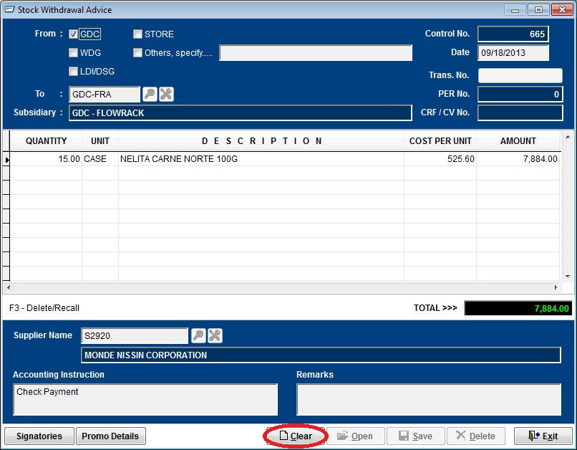

1. After the Stock Withdrawal Advice has been created and approved. Using the transaction numbers in the Navision/Designex systems to confirm the SWA. From the main menu go to STOCK WITHDRAWAL ADVICE > SWA CONFIRMATION – MIS.

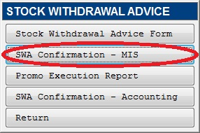

1. Locate the SWA using the control number as a guide, then press enter key to enter the transaction number.

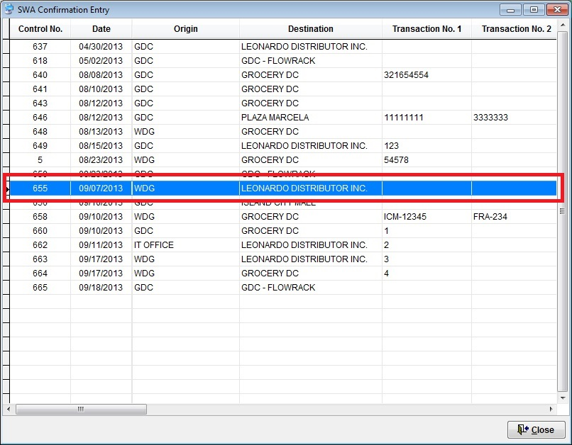

1. Type the transaction number using the Navision / Designex transaction number to confirm the stock withdrawal.

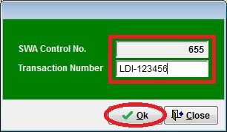

**P**ROMO

**E**XECUTION

**R**EPORT

By :**FELJUN BUENO**

1. To enter promo execution report, from the main menu click on STOCK WITHDRAWAL ADVICE > PROMO EXECUTION REPORT.

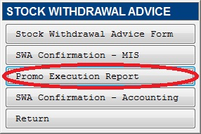

* 1. To create Promo Execution Report.
     1. Click NEW button
     2. Type current date
     3. Enter the SWA Series number to retrieve an existing SWA file
     4. Enter the actual execution quantity and the un-used quantity allocated
     5. Type the execution summary
     6. Type post promo remarks

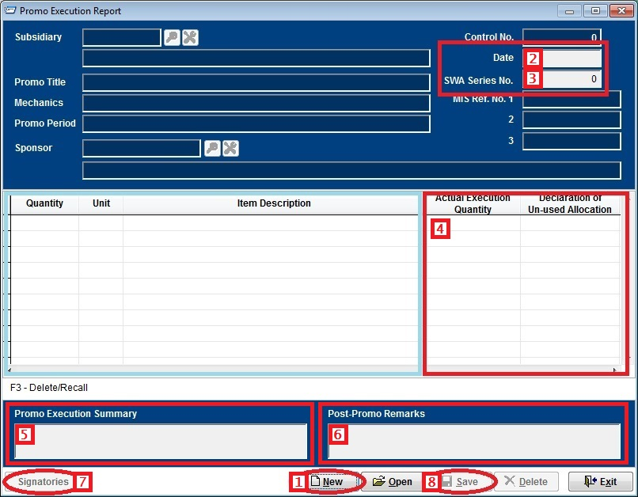

* + 1. For the signatories, click on the SIGNATORIES button

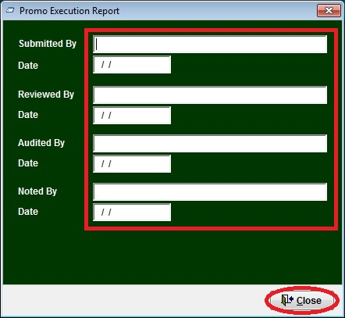

* + 1. Next is to save and print the PER form. Just click on the SAVE button, then follow the steps bellow.

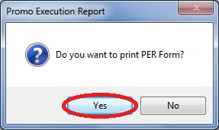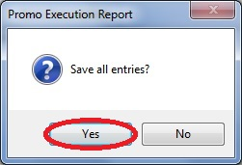

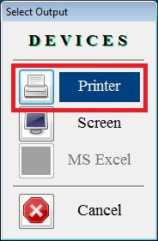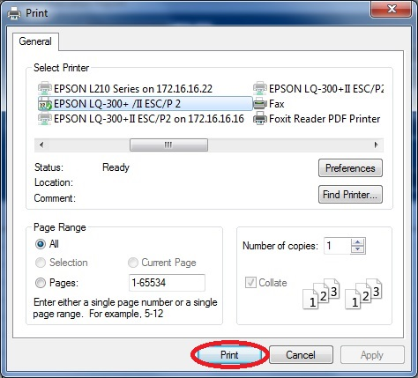

1. After the SWA form has been created and approved. Using the accounting transaction number in the Navision/Designex systems to confirm the SWA. From the main menu go to STOCK WITHDRAWAL ADVICE > SWA CONFIRMATION – ACCOUNTING.



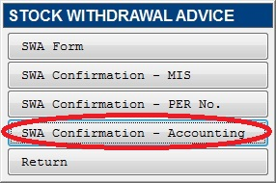

1. Locate the SWA using the control number as a guide, then press enter key to enter the accounting transaction number.

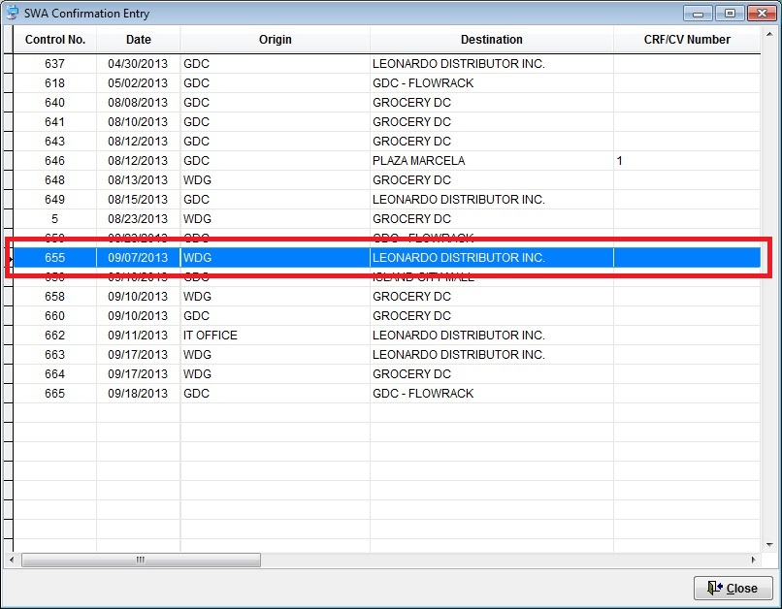

1. Type the CRF/CV transaction number using the Navision / Designex transaction number.

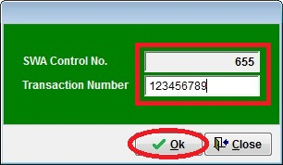

**System Utilities**

1. To change the wallpaper, from the main menu select SYSTEM UTILITIES > SYSTEM WALLPAPER.

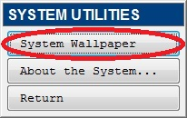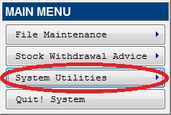

1. Click BROWSE button to select a picture you want to be the wallpaper in your screen.

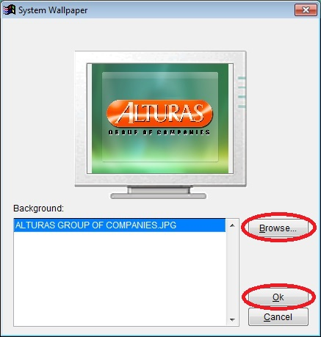

1. Then click OK button to accept picture.

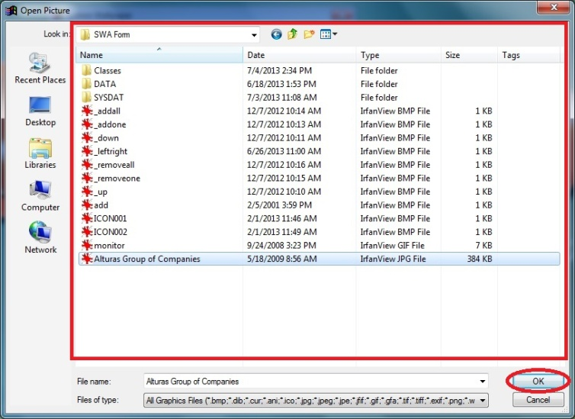

1. Then press OK again in the Wallpaper window to apply the picture as the system wallpaper.
2. To view the system information, from the main menu select SYSTEM UTILITIES > ABOUT THE SYSTEM....

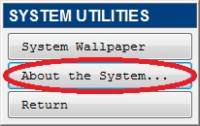

1. About the stock withdrawal advice monitoring system.

